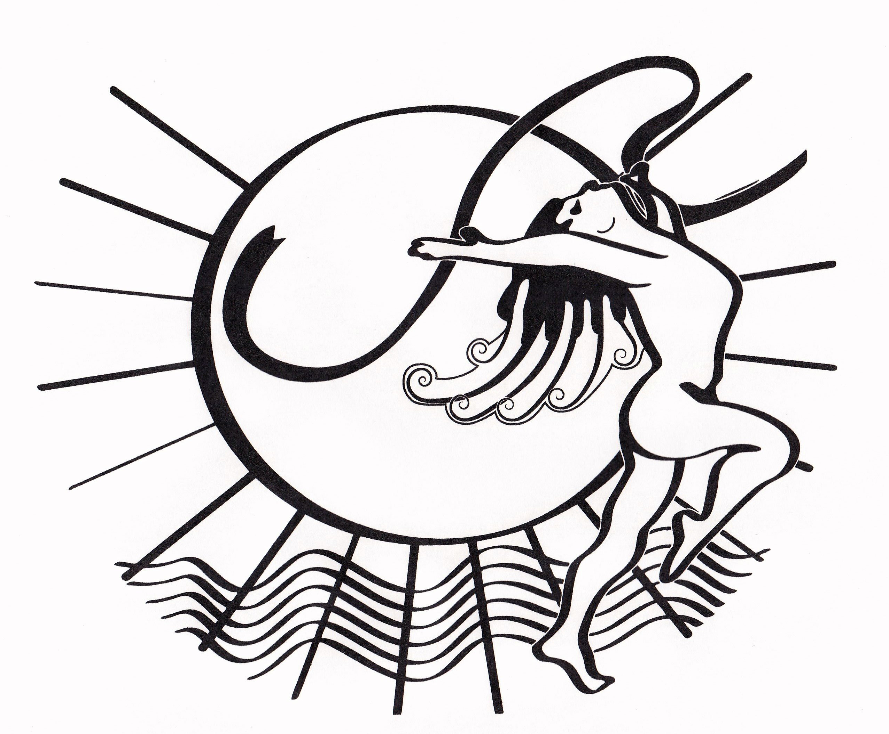
Perth Theatre Project O/A Studio Theatre

PROXY CARD
FILL OUT ONLY IF UNABLE TO ATTEND AGM MEETING
Must be presented to the Treasurer before the meeting to obtain a ballot card

NAME:

I Authorize (Name) _________________________________________ to

vote purchase a membership

on my behalf at the AGM, June 6, 2024

Signature ___________________________________________________

Date ________________________________

Perth Theatre Project O/A Studio Theatre

PROXY CARD
FILL OUT ONLY IF UNABLE TO ATTEND AGM MEETING
Must be presented to the Treasurer before the meeting to obtain a ballot card

NAME:

I Authorize (Name) _________________________________________ to

vote purchase a membership

on my behalf at the AGM, June 6, 2024

Signature _____________________________________________________________________________

Date _______________________________________

